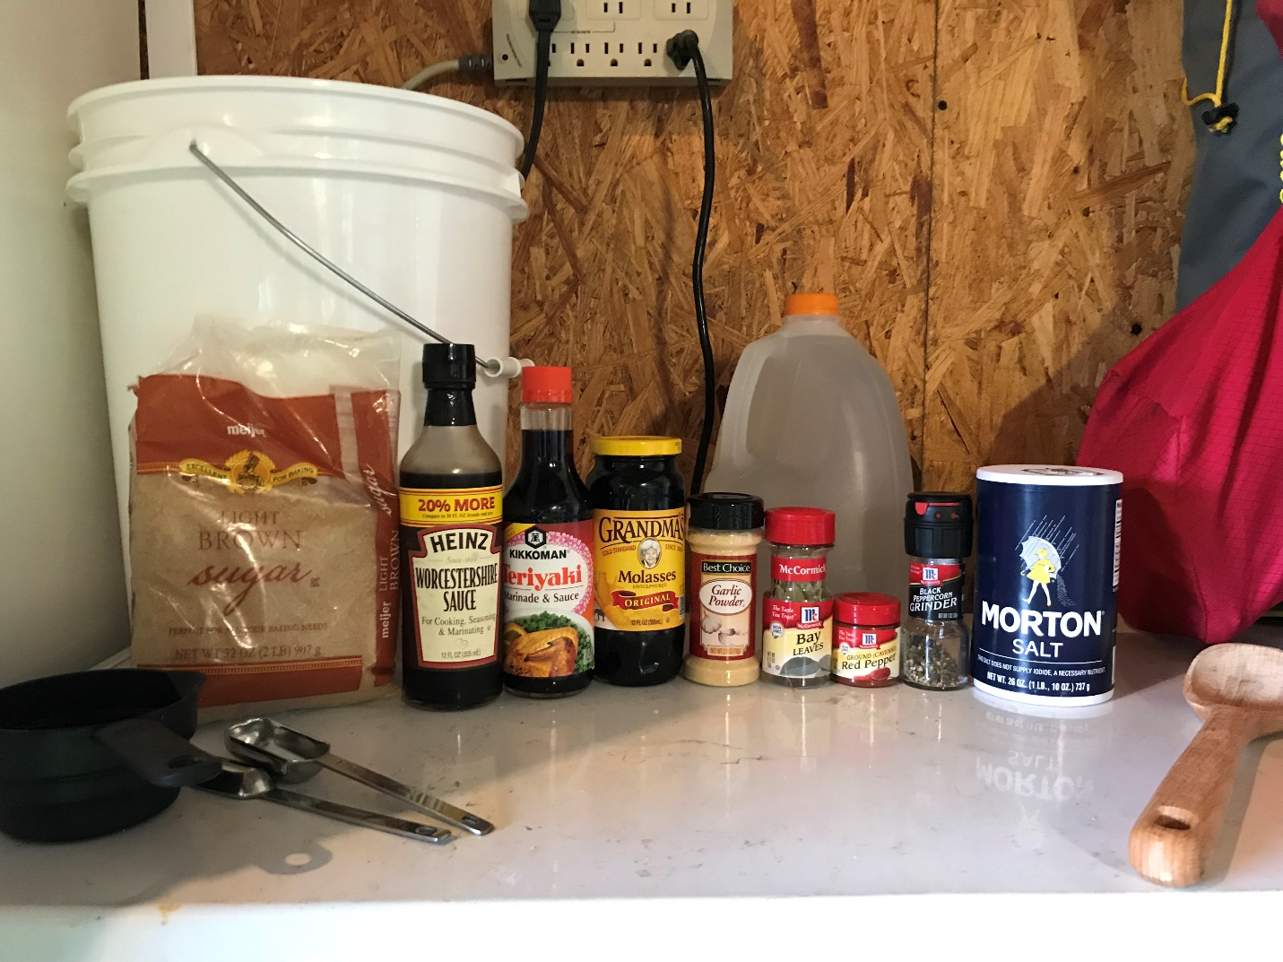
CAPTAIN MUG’S FAMOUS SMOKED SALMON RECIPE
This is a family tried and true recipe that has been passed down generations. Your catch will never taste any better once you try it.

Ingredients:
Crock (a big enough container to brine your catch, we suggest a food safe 5 gallon bucket)
1 Gallon of water
1 Cup Salt
½ lb. Dark Brown Sugar
15oz. bottle of Molasses
5 Bay Leaves
1 Cup Teriyaki Sauce
2 Tbsp of Worcestershire Sauce
1 Tsp Coarse Black Pepper
1 Tsp Cayenne Pepper
1 Tsp Garlic Powder
Directions:
Mix all ingredients together well in crock.
Add Salmon fillets, make sure that all fillets are covered by the brine.
Place in fridge for 2-3 days, stirring daily
Take out of brine and let air dry, in fridge, until sticky to the touch.
Smoking instruction:
Start smoker and let it reach 160° F, with damper half open so there is a good amount of smoke in the chamber.
Spray smoking grates with non-stick cooking oil, place fillets skin down, brush top with honey, sprinkle with coarse ground black pepper and dark brown sugar.
Smoke for 3.5 hours at 160° F.

