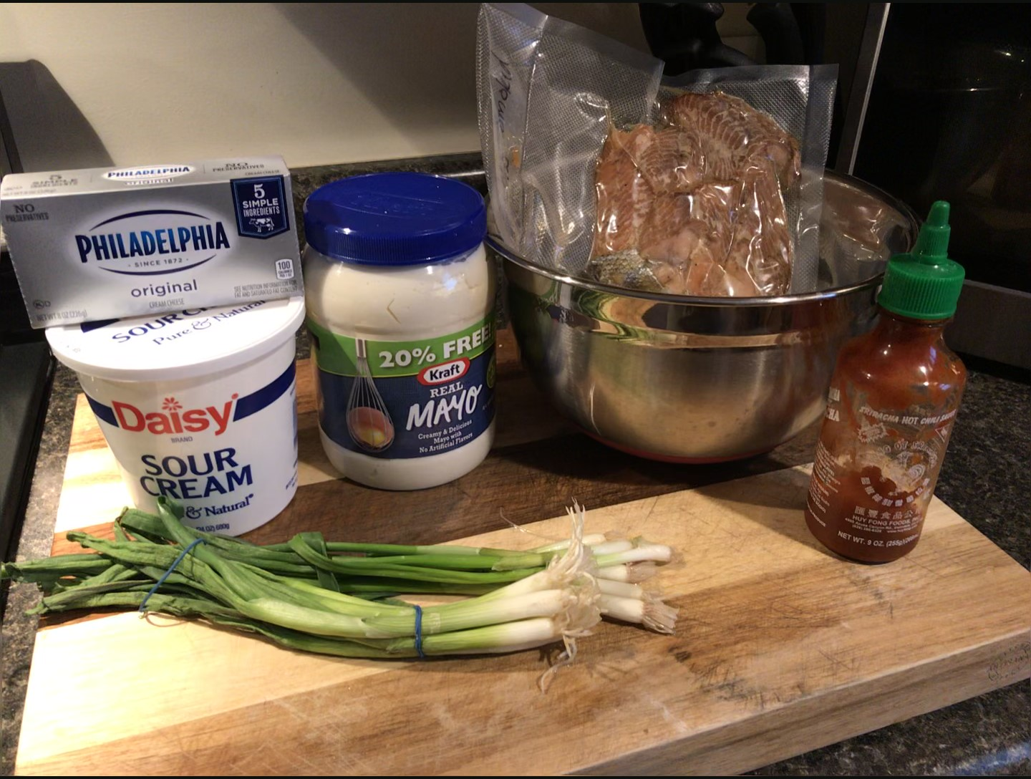
SMOKED SALMON DIP
A great way to use up some of Captain Mugs Famous Smoked Salmon for a get together.

Ingredients:
1 pound or One fillet of Captain Mugs Famous Smoked Salmon chunked into pieces
8oz. package of cream cheese
½ cup of Mayonnaise
½ cup of Sour Cream
6 Green onions chopped
2 Tbsp of Lemon juice
2 Tsp Siracha hot sauce
1 Tbsp of Sea Salt
Directions:
Combine all ingredients in a large mixing bowl mixing thoroughly. I find that if you let the cream cheese sit out for an hour before mixing it allows it to mix easier. Once mixed put back in fridge for an hour. Plate and serve with your favorite cracker, we prefer Ritz or Club crackers. Enjoy!!!

